Lung Disease Dataset
(COMP3125 Individual Project)

Thomas Do

Introduction (Heading 1)
In this project, I explored the relationship between age, lung capacity, and smoking status. Using a dataset that included individuals of various ages, along with their lung capacity measurements and whether or not they smoked, I created visual plots to identify trends and differences. The goal was to observe how lung function changes over time and to examine the impact of smoking on respiratory health. Through this analysis, I found noticeable patterns suggesting that smokers generally show a decline in lung capacity at a faster rate compared to non-smokers. The project helped demonstrate the long-term effects of smoking and highlighted the importance of lung health monitoring.

Source of dataset (Heading 2)
The dataset used for this project was sourced from Kaggle, a reputable platform widely used by data scientists and researchers for accessing and sharing datasets. It was contributed by a verified user and is designed to support research related to lung health and respiratory diseases. The dataset contains a variety of relevant health-related attributes, including age, lung capacity, smoking status, presence of lung diseases (such as asthma or chronic obstructive pulmonary disease), and details on any treatments or medical interventions received.
The data was originally compiled to analyze the long-term effects of smoking and age on lung function. It includes records from individuals across a wide age range, allowing for a comprehensive exploration of how lung health changes over time. The dataset was generated through health surveys and clinical assessments, ensuring a level of accuracy and credibility in the information provided.
Dalvi, Samiksha. “Lungs Diseases Dataset.” Kaggle, 25 Feb. 2025, www.kaggle.com/datasets/samikshadalvi/lungs-diseases-dataset.

Character of the datasets

Lung Disease Dataset Summary
Attribute | Type | Description | Unit / Format | Missing Values
Age | Numeric | Patient's age | Years | 300
Gender | Categorical | Gender of the patient | Male / Female | 300
Smoking Status | Categorical | Indicates if patient is a smoker | Yes / No | 300
Lung Capacity | Numeric | Lung capacity measurement | Liters | 300
Disease Type | Categorical | Type of lung disease diagnosed | COPD, Bronchitis, etc. | 300
Treatment Type | Categorical | Treatment administered | Surgery, Medication, etc. | 300
Hospital Visits | Numeric | Number of hospital visits | Count | 300
Recovered | Categorical | Indicates if patient recovered | Yes / No | 300

Dataset Format & Size
Aspect | Detail
File Format | CSV
Size | 5,200 x 8

Methodology
In this project, I used Logistic Regression to predict whether a patient is a smoker or non-smoker based on features such as age, lung capacity, treatment type, and hospital visits. Logistic Regression is ideal for this type of binary classification task because it models the probability of a patient belonging to one of two categories.
The model was implemented using Python’s sklearn.linear_model.LogisticRegression() function. Before training, I prepared the data by encoding categorical variables and handling missing values. Optional preprocessing like feature scaling was also considered to improve model performance. To support the analysis, I created a scatter plot showing the relationship between Age and Lung Capacity. This visualization helped identify patterns across different age groups that might influence smoking behavior. For example, lower lung capacity in certain age ranges could indicate a higher likelihood of being a smoker.
Logistic Regression was chosen for its simplicity, efficiency, and interpretability—making it a reliable model for predicting smoking status based on patient health data.

Method B
- Logistic Regression

Identify applicable funding agency here. If none, delete this text box.

Results
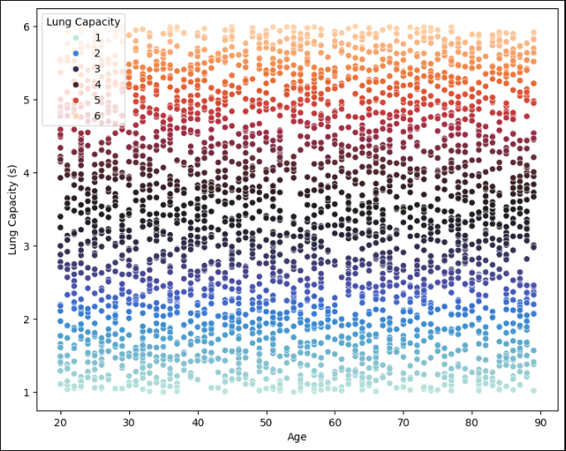

The scatter plot shows the relationship between age and lung capacity, with each point representing an individual and color-coded by lung capacity levels from 1 to 6. The data appears grouped in horizontal bands, indicating lung capacity tends to cluster around certain values rather than varying smoothly with age. There is no strong visual correlation between age and lung capacity, suggesting other factors may play a more significant role.
Below the plot, two model performance metrics are shown: the Mean Squared Error (MSE) is 2.1977, and the Root Mean Squared Error (RMSE) is 1.4825. These values indicate the average error in predicting lung capacity, with the RMSE suggesting that the model's predictions deviate from the actual values by about 1.48 seconds on average. This implies a moderate prediction accuracy, with room for improvement potentially by including more relevant features.

Results C
- Table Type Styles
- 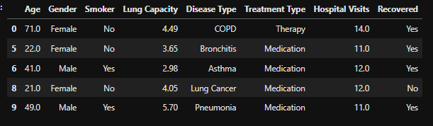
- 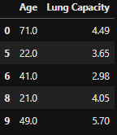
- Example of a figure caption. (figure caption)

Discussion
One of the main weaknesses in my project was the overall performance of the results. While I was able to build a model and generate visualizations, I feel that the outcome—particularly the accuracy of the predictions—was not as strong as it could have been. The RMSE value of 1.4825 indicates a moderate level of error, and I believe there was definitely room for improvement in terms of model accuracy and interpretation of patterns in the data. I recognize that I could’ve done a better job at refining the model. Including additional features that might have a stronger influence on lung capacity, such as health conditions, lifestyle factors, or environmental exposure. For future work, I would focus on collecting more comprehensive data, trying different modeling approaches, and conducting deeper exploratory data analysis to better understand the underlying trends. These steps would likely lead to more reliable and meaningful results

Conclusion
In this project, I explored the relationship between age, lung capacity, and other possible contributing factors, with a particular focus on the impact of smoking. By analyzing the data and building a predictive model, I aimed to understand how lung capacity changes over time and what influences it the most. Although the results showed some variability and room for improvement, one clear takeaway is the significant role lifestyle choices especially smoking, can play in lung health. The data suggested that lung capacity doesn’t decline solely due to age; instead, external factors like smoking likely contribute to reduced lung function.
This is an important finding because it emphasizes the need for greater awareness about the harmful effects of smoking. In real-world terms, lower lung capacity can lead to serious health issues, reduced physical endurance, and long-term respiratory diseases. By promoting healthier habits and early prevention, especially among younger individuals, we can potentially preserve lung function and improve overall quality of life. This project reinforces the message that taking care of your lungs through smart lifestyle choices can make a real difference.

Acknowledgment

I sincerely thank Dr. Pang for your generous support, guidance, and encouragement throughout this work. your contributions have been invaluable.

References
“Dalvi, Samiksha. “Lungs Diseases Dataset.” Kaggle, 25 Feb. 2025, www.kaggle.com/datasets/samikshadalvi/lungs-diseases-dataset.”

